**Q. Write a program to Delete all table rows except the first one using jQuery.**

**CODE:**

<!DOCTYPE html>

<html lang="en">

<head>

<meta charset="UTF-8">

<script src="https://code.jquery.com/jquery-3.1.1.min.js"></script>

<title>Delete table rows</title>

<style>

table,

th,

td {

border: 2px solid black;

text-align: center;

}

</style>

</head>

<h3>Click to delete all table rows except the 1st row</h3>

<button id="btn">Click</button>

<body>

<table id="rTable">

<tr>

<th>No.</th>

<th>Name</th>

<th>Age</th>

</tr>

<tr>

<td>1</td>

<td>A</td>

<td>20</td>

</tr>

<tr>

<td>2</td>

<td>B</td>

<td>21</td>

</tr>

<tr>

<td>3</td>

<td>C</td>

<td>22</td>

</tr>

</table>

</body>

<script>

$('#btn').click(function () {

$('#rTable').find("tr:gt(1)").remove();

});

</script>

</html>

**OUTPUT:**

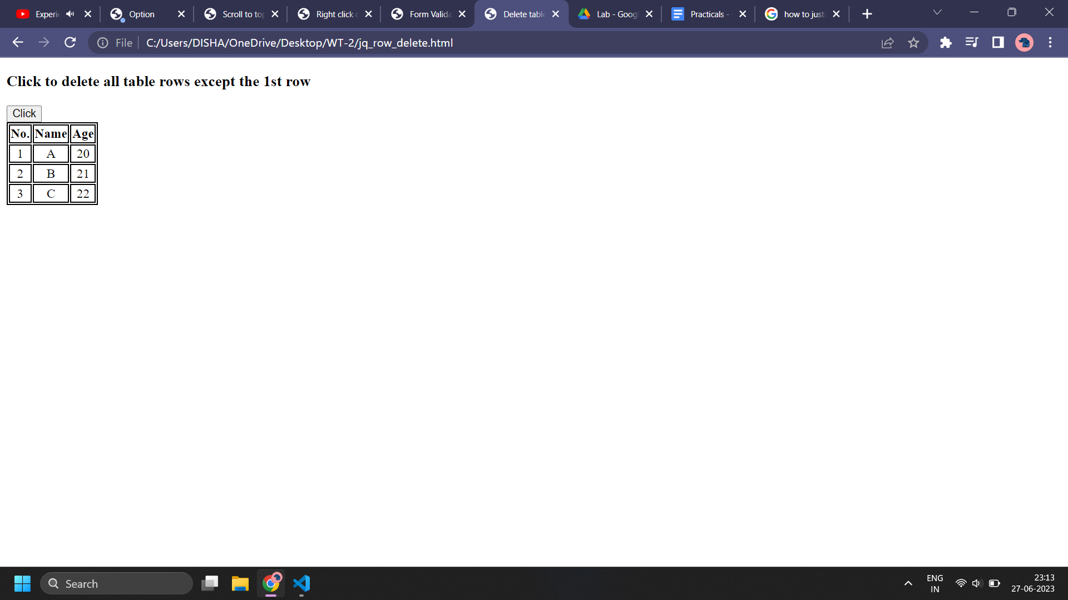

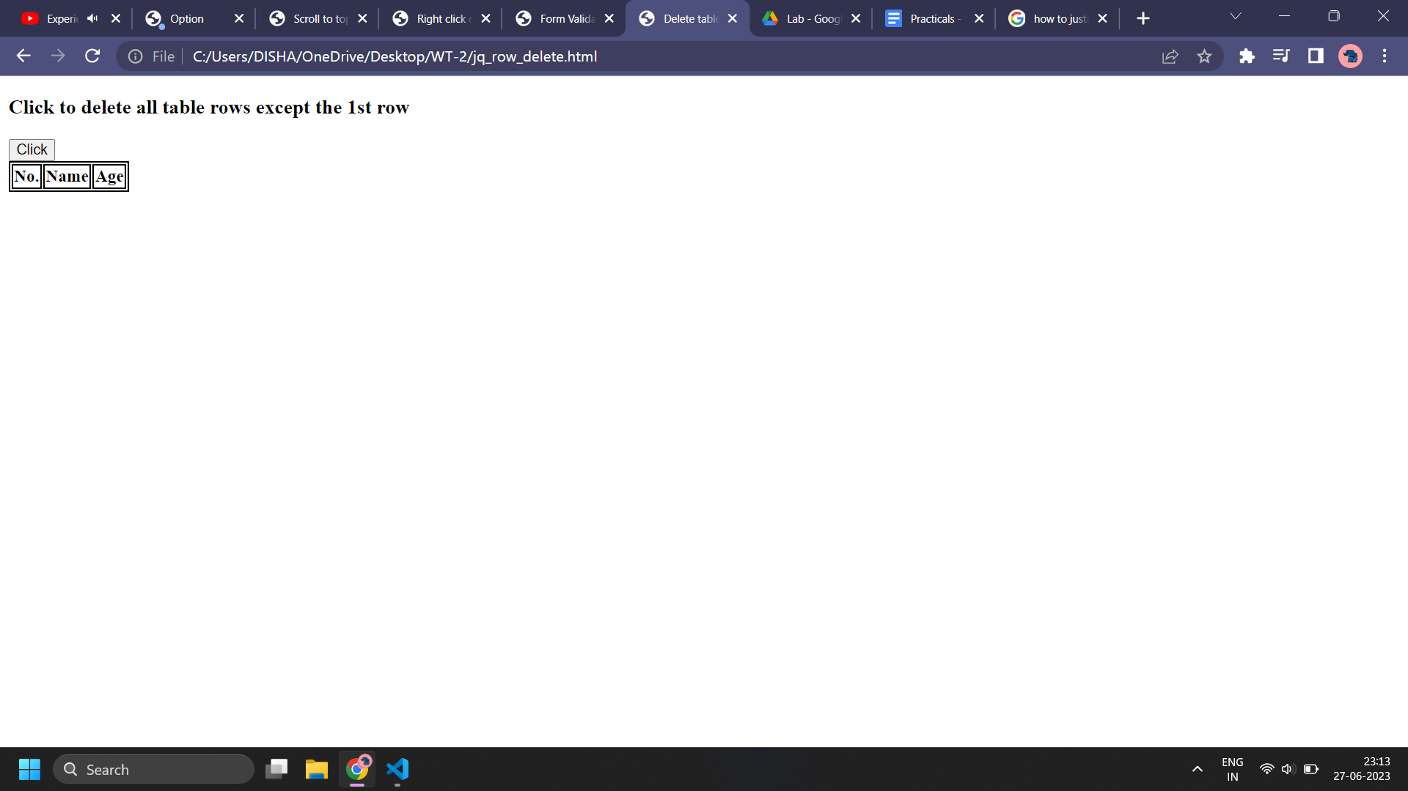

**Q. Disable right click.**

**CODE:**

<!DOCTYPE html>

<html lang="en">

<head>

<meta charset="UTF-8">

<title>Right click disabled</title>

<script src="https://ajax.googleapis.com/ajax/libs/jquery/3.6.4/jquery.min.js"></script>

<script>

$(document).ready(function () {

$(document).bind("contextmenu", function (e) {

return false;

});

});

</script>

</head>

<body>

<center>

<h1>Heading</h1>

<p>Lorem, ipsum dolor sit amet consectetur adipisicing elit. Tenetur quaerat magnam saepe possimus

consectetur distinctio quae ratione, sed sit sint perspiciatis. Corporis, consequuntur. Facilis quam,

odio non dicta et similique?

Impedit praesentium illum repellendus quasi reprehenderit distinctio illo incidunt quibusdam, doloremque

temporibus, placeat eveniet ducimus maxime aut? Alias fugiat velit dolor quibusdam ex.

</p>

</center>

</body>

</html>

**OUTPUT:**

